Scripture Advent Calendar

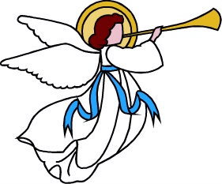

The following scriptures are the prophecies of the coming of Jesus Christ and the account of his birth. Each day in December, light a candle as you read the scriptures for that day.

Dec. 1: Abraham 3:22-28

Dec. 2: Moses 5: 4 – 15

Dec 3: Moses 6:50-63

Dec 4: Ether 3: 6-14

Dec 5: Genesis 49: 10
Numbers 24:17
Deut. 18:15-18

Dec 6: Psalms 2:7
Psalms 24 (JST)

Dec 7: Psalms 68: 18-20
Psalms 118: 14-24

Dec 8: Isaiah 7:14-15
Isaiah 9:6-7
Isaiah 11:1-5

Dec 9: Isaiah 25:6-9
Isaiah 40:1-5

Dec 10: Isaiah 42:1-10

Dec 11: Isaiah 53

Dec 12: Isaiah 61:1; 59:20
Jeremiah 23:5-8

Dec 13: I Nephi 10: 1-10, 17

Dec 14: I Nephi 11: 9-23

Dec 15: I Nephi 19: 7-20
I Nephi 22: 20-21

Dec 16: II Nephi 25:19-26
Jacob 4: 4-6

Dec 17: Micah 5:2
Hosea 11:1

Dec 18: Zech 6:12-13
Malachi. 3:1

Dec 19: Mosiah 3:5-8
Mosiah 13: 27-35

Dec 20: Alma 5:50
Alma 7:7-12

Dec. 21: Helaman 8: 13-20, 22-23

Dec 22: Helaman 14:1-8, 11-13

Dec 23: Luke 1:5 -80

Dec 24: 3 Nephi 1:4-21
Matt 1:18-25

Dec 25: John 1: 1-14
Luke 2:1-40
Matt 2

